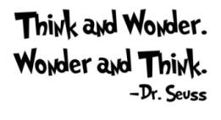
K-Note
Please return daily in the blue homework folder.

Week of September 30 - October 4

Monday Night
- Our story for the week is We Go. (Pre-decodable Book #9)
- I added we & go to the sight words we are practicing.

Tuesday Night
- Show-n-tell is tomorrow. Bring something that starts with LETTER P. The P treat is Pretzels.

Wednesday Night

Thursday Night

Friday Night

This is what we are learning about this week in school.

In Writing, we are practicing our first and last name and the letter P.
In Reading, our story for the week is (#9 Pre-decodable) We Go.
In Phonemic Awareness, we are practicing: rhyming words, beginning sounds, syllables in words, final sounds, segmenting words into syllables, substituting a word to create a new word, adding suffixes at the end of a word to create a new word, deleting a suffix from a word, and language awareness.
In Math, we are learning about: counting 9 - 10 objects in a line and array patterns; matching 9 - 10 objects to the number 9 or 10; and writing numbers 9 and 10.
In Science, we are learning about pumpkins.
In Art, we made a capital P-pig and a lowercase p-peacock. We will also make our grandparents projects.
During story time, I’m reading books about pumpkins.
In Health, Mr. Dan from the U of I extension office will be here to talk about nutrition and body systems.
Coin Store, we had coin store on Monday.

